COMIICCRAFT-AI COMIC STORY CREATOR USING GEMINI MODELS
Project Documentation
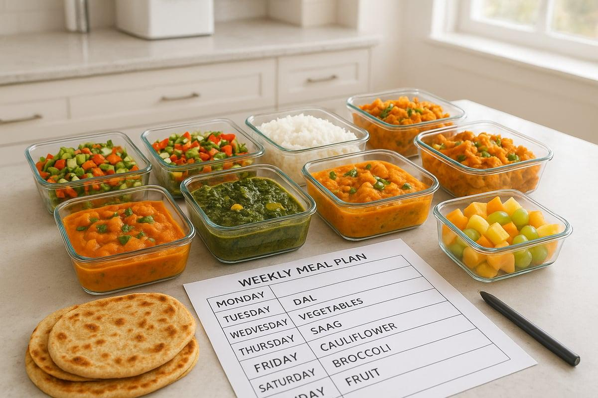

Project Description
Healthy Diet & Meal Planner is a web-based application designed to help users organize balanced meals using practical food choices. The system collects preferences such as vegetarian or non-vegetarian pattern, preferred cuisine, available ingredients, meal frequency, cooking time, and planning duration.
The application produces a structured weekly meal schedule with breakfast, lunch, dinner, and optional snacks. It also provides ingredient lists, preparation guidance, portion reminders, and a printable meal-plan report.
The project focuses on balanced eating rather than extreme dieting. WHO describes healthy diets using the principles of adequacy, balance, moderation, and diversity, with emphasis on vegetables, fruits, pulses, whole grains, nuts, and other nutritious foods. citeturn0search0

Project Scenarios

Scenario 1: Creating a Balanced Weekly Plan
A user selects a preferred food pattern, enters commonly available foods, chooses the number of meals per day, and selects seven planning days. The application organizes meals across the week.

Scenario 2: Planning a Quick-Cooking Menu
A user selects a short cooking-time preference. The system prioritizes simple preparations such as idli with sambar, vegetable upma, oats, dal-rice combinations, curd-based sides, salads, fruits, and other practical options.

Scenario 3: Using Local Indian Foods
The planner can use familiar foods such as rice, wheat, millets, pulses, vegetables, fruits, curd, eggs, fish, and other foods according to the user's dietary pattern. WHO India notes that healthy diets can include cereals, legumes, vegetables, fruits, and animal-source foods such as meat, fish, eggs and milk. citeturn0search5

Scenario 4: Printing the Weekly Plan
After reviewing the schedule, the user can export the weekly plan as a PDF for reference while shopping and preparing meals.

Technical Architecture
The application follows a three-layer architecture: web frontend, FastAPI backend, and food-data/reporting layer.

Pre-requisites
- FastAPI Framework Knowledge
- Uvicorn ASGI Server
- Python Programming Proficiency
- HTML, CSS, and Jinja2 Template Skills
- SQLite Database Basics
- SQL CRUD Operations
- Basic Nutrition and Food-Group Knowledge
- PDF Generation
- Git Version Control
- Python Package and Virtual Environment Setup

Project Workflow
- Milestone 1. Requirements and Architecture
- Activity 1.1. Identify meal-planning requirements
- Activity 1.2. Define food groups and application architecture
- Activity 1.3. Set up development environment
- Milestone 2. Core Meal-Planning Functions
- Activity 2.1. Develop meal and recipe functions
- Activity 2.2. Implement FastAPI backend and food database
- Milestone 3. routes.py Development
- Activity 3.1. Write the main application routes
- Milestone 4. Frontend Development
- Activity 4.1. Design the meal-planning interface
- Activity 4.2. Create dynamic Jinja2 templates
- Milestone 5. Deployment and Testing

Milestone 1. Requirements and Architecture

Activity 1.1: Identify Project Requirements
The application should help users plan meals that contain a variety of food groups while considering practical constraints.
- Breakfast, lunch, dinner, and optional snack planning
- Vegetables and fruits across the week
- Whole grains or other minimally processed carbohydrate choices
- Pulse, egg, fish, lean meat, dairy, or other protein choices according to preference
- Ingredient availability
- Cooking-time preference
- Meal frequency and planning duration
- Printable weekly plan

Healthy Diet Principles
WHO identifies adequacy, balance, moderation, and diversity as core principles of healthy diets. It also recommends a varied diet with vegetables, fruits, legumes, nuts and whole grains, while limiting free sugars, unhealthy fats and excess sodium. citeturn0search0turn0search2

Activity 1.2: Define the Architecture of the application

Frontend Responsibilities
- Collect food preferences and planning duration
- Display weekly meal cards
- Show ingredients and preparation steps
- Provide print/export action

Backend Responsibilities
- Validate user inputs
- Read food and recipe data
- Build a weekly meal schedule
- Calculate simple meal summaries
- Prepare report data

Activity 1.3: Set Up the Development Environment
Create a Python virtual environment and install the required packages.
python -m venv diet-planner-env
diet-planner-env\Scripts\activate # Windows
pip install fastapi uvicorn jinja2 python-multipart fpdf2 python-dotenv
Run the development server:
uvicorn app.main:app --reload
Visit http://127.0.0.1:8000 for the application and /docs for FastAPI API testing.

Initial Project Structure
- app/main.py
- app/routes.py
- app/database.py
- app/models.py
- app/meal_planner.py
- app/reports.py
- templates/index.html
- templates/meal_plan.html
- templates/recipe.html
- templates/report.html
- static/css/style.css
- static/images/
- static/exports/
- requirements.txt

Milestone 2. Core Meal-Planning Functions

Activity 2.1: Develop Core Functionalities

Build Weekly Meal Plan
Function: build_weekly_plan()
- Reads user preferences
- Selects suitable foods from the food database
- Creates breakfast, lunch, dinner and optional snack entries
- Keeps meals varied across the week

Create Recipe Details
Function: get_recipe_details()
- Returns ingredients
- Returns preparation steps
- Provides approximate cooking time
- Provides serving and portion notes

Prepare Shopping List
Function: build_shopping_list()
- Collects ingredients used by the selected meals
- Combines repeated ingredients
- Groups items by food category

Food Groups and Meal Composition

Vegetables and Fruits
Include a variety of vegetables and fruits across meals and snacks. WHO recommends at least 400 g of fruits and vegetables per day for people older than 10 years, with age-specific lower amounts for younger children. citeturn0search0

Whole Grains and Pulses
Examples include oats, millet, wheat, brown rice, lentils, chickpeas, beans and other pulses. WHO identifies whole grains, vegetables, fruits and pulses as important carbohydrate sources. citeturn0search0

Protein Foods
The planner can include pulses, beans, eggs, fish, lean meat, curd, paneer or other suitable choices based on the selected dietary pattern.

Healthy Fats
Nuts, seeds and unsaturated plant oils can be used in appropriate amounts. Highly processed and fried foods should be limited. citeturn0search0turn0search12

Activity 2.2: Implement the FastAPI Backend

Process User Input
- HTML form collects diet pattern, cuisine, ingredients, meals per day and duration.
- FastAPI receives form values.
- Pydantic models validate structured API requests.
- Meal-planning functions prepare the weekly schedule.

Main Routes
- / → loads the planner homepage
- /create-plan → receives preferences and creates the meal plan
- /meal-plan → displays the weekly plan
- /recipe/{id} → displays recipe details
- /shopping-list → displays combined ingredients
- /report → prepares the printable report
- /export-report → returns the PDF

Validation
The backend checks required fields, valid planning duration, valid meal count, and acceptable text values before building the plan.

Milestone 3. routes.py Development

Activity 3.1: Writing the Main Application Logic
- Load planner homepage.
- Capture meal preferences.
- Validate submitted information.
- Call build_weekly_plan().
- Send the plan to meal_plan.html.
- Provide recipe details and shopping list.
- Create a printable report.
- Handle invalid requests with clear messages.

Route Workflow
The route connects user input to the meal-planning service, then passes the structured result to the Jinja2 template for display.

Milestone 4. Frontend Development

Activity 4.1: Designing and Developing the User Interface
- Dietary pattern
- Cuisine preference
- Available ingredients
- Cooking time
- Meals per day
- Planning duration
- Breakfast / lunch / dinner cards
- Shopping-list action
- Print / export action

Responsive Layout
- Use meal cards for each day.
- Use readable headings and labels.
- Keep the form short and clear.
- Use a grid for desktop and a stacked layout for smaller screens.
- Provide a clear print/export button.
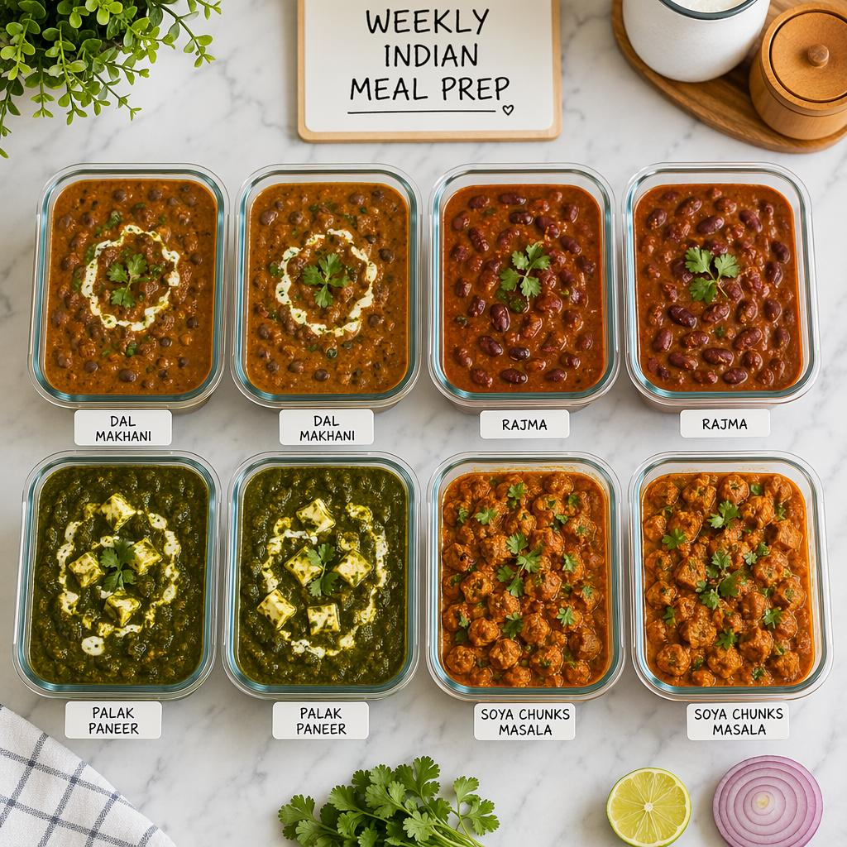

Activity 4.2: Creating Dynamic Templates with Jinja2
from fastapi.templating import Jinja2Templates
templates = Jinja2Templates(directory="templates")

Template Pages
- index.html – planning form
- meal_plan.html – weekly meal schedule
- recipe.html – ingredients and preparation
- shopping_list.html – combined ingredients
- report.html – printable summary

Dynamic Binding
The weekly plan is passed as template data. Jinja2 loops display day names, meal names, ingredients and preparation steps without hard-coded content.

Milestone 5. Deployment

Activity 5.1: Preparing the Application
python -m venv env
env\Scripts\activate
pip install -r requirements.txt

Configuration
- Store database path in .env.
- Store report directory in configuration.
- Keep recipe and food data in a structured local database or JSON/CSV source.
- Keep static images in the static/images directory.

Activity 5.2: Testing and Verification
uvicorn app.main:app --reload

Testing Checklist
- Open the planner.
- Enter valid food preferences.
- Create a 7-day plan.
- Verify that every day has the selected meal types.
- Open recipe details.
- Check ingredient list.
- Open shopping list.
- Print/export the weekly plan.
- Test invalid or missing input.
- Restart the application and verify stored data.

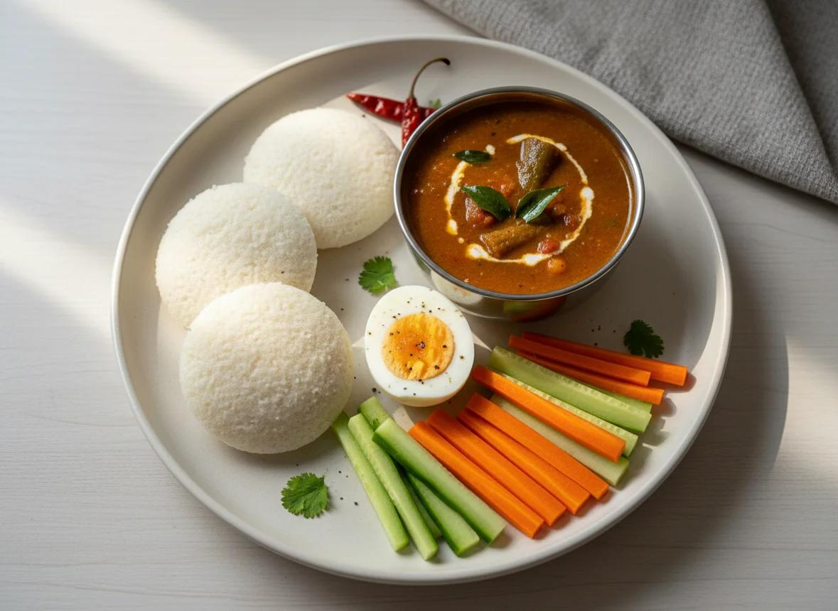

Exploring Website Pages

Home Page
The homepage provides the main planning form. Users select food preferences and planning duration.

Meal Plan Page
The result page displays the weekly schedule day-by-day, with meal names and preparation details.

Recipe Page
The recipe page displays ingredients, preparation steps, approximate cooking time, and serving notes.

Shopping List Page
The shopping list combines ingredients from the selected weekly meals so users can organize grocery purchases.
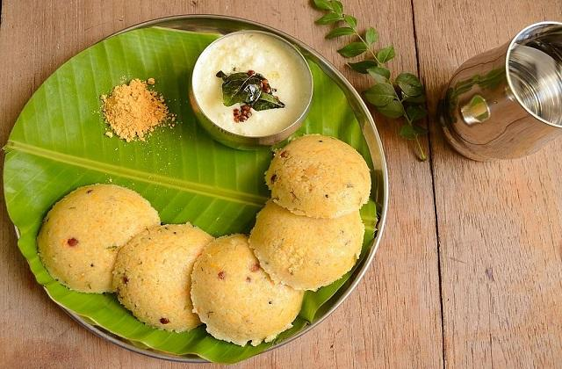

Healthy Meal Planning Guidance

Sample Breakfast Options
- Idli + sambar + fruit
- Vegetable upma + curd
- Oats porridge + fruit + nuts
- Dosa + sambar + vegetable side
- Vegetable poha + curd

Sample Lunch Options
- Rice + dal + two vegetable sides + curd
- Chapati + chana + vegetable side
- Millet-based meal + dal + vegetables
- Rice + fish/egg + vegetables
- Vegetable khichdi + curd

Sample Snack Options
- Whole fruit
- Unsalted nuts in an appropriate portion
- Curd with fruit
- Roasted pulses
- Vegetable snack

Sample Dinner Options
- Chapati + dal + vegetables
- Vegetable dosa + sambar
- Light rice-and-dal meal + vegetables
- Millet dosa + vegetable side
- Soup + whole-grain accompaniment + protein source

Project Images and Flow Charts

1. System Architecture Diagram
Figure 1: Architecture connecting the web interface, FastAPI backend, food database, and meal-plan/report layer.

2. End-to-End Meal Planning Flow Chart
Figure 2: Complete flow from user preferences to weekly meal plan and export.
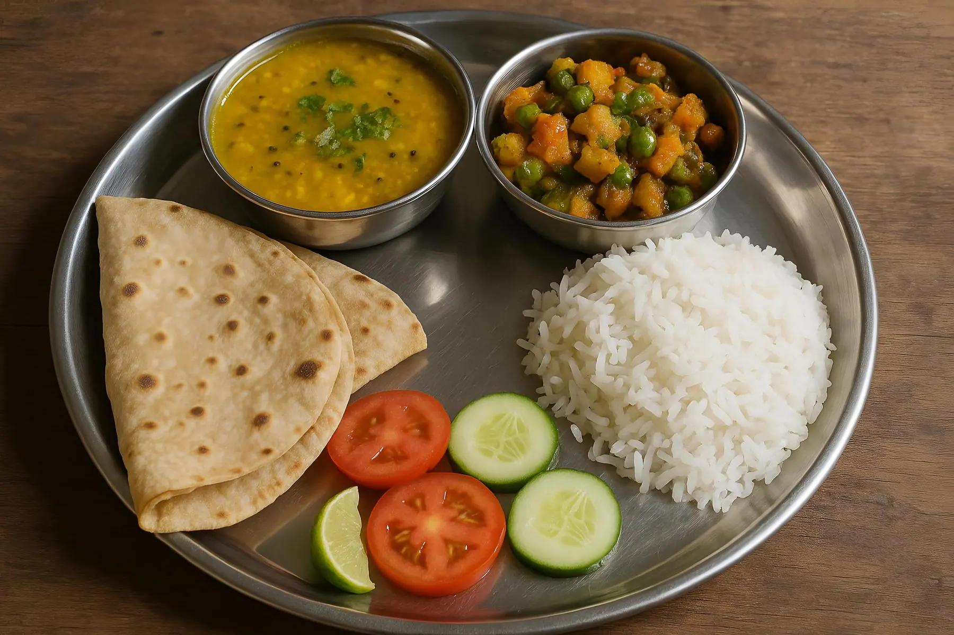

3. Balanced Meal Plate Illustration
Figure 3: A visual representation of major food groups that can be combined into a balanced meal.
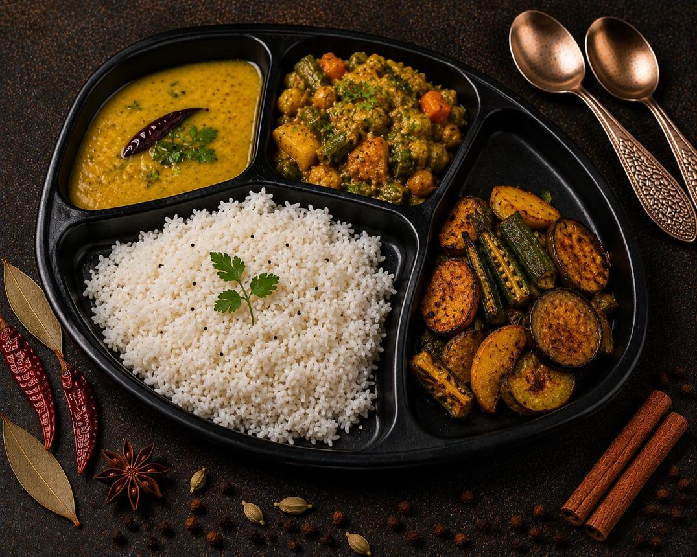

4. Real Food Photo References
The following are real food photographs hosted by Unsplash and can be used as photo references in the final presentation/document. They are not AI-generated illustrations.
Real photo: Idli and sambar with coffee – Unsplash
Real photo: Idlis with chutneys and sambar – Unsplash
Real photo: Idli, vada and sambar – Unsplash

Real Photo Sources and Usage Notes
The photographs listed below were checked as free-to-use photographs on Unsplash at the time of research. The individual photo pages identify the photographer and the Unsplash license. For example, the idli-and-sambar photograph is described as a free HD photo and the page states that it is free to use under the Unsplash License. citeturn2view0

Photo Source 1
Unsplash – Idli and sambar with coffee
Use for: South Indian breakfast / healthy breakfast section.

Photo Source 2
Unsplash – Idlis with chutneys and sambar
Use for: traditional Indian meal / breakfast illustration.

Photo Source 3
Unsplash – Idli, vada and sambar
Use for: South Indian food example.
Note: The Word document includes source links rather than copying third-party photographs into the file, so the original photographer/license information remains attached to the source page.

Expected End-to-End Flow
- User opens the Healthy Diet & Meal Planner.
- User enters dietary and meal preferences.
- FastAPI validates the information.
- Meal-planning functions select suitable meals.
- The weekly schedule is generated.
- The user reviews meals and recipes.
- Ingredients are combined into a shopping list.
- The user prints or exports the plan.
- The weekly plan can be used for meal preparation.

Important Nutrition Note
A healthy diet is not a single fixed menu. WHO notes that the exact composition varies with individual characteristics, lifestyle, cultural context, locally available foods and dietary customs. citeturn0search0turn0search1

Conclusion
Healthy Diet & Meal Planner demonstrates how a simple web application can organize practical, varied meal choices into a structured weekly plan. The project combines FastAPI, SQLite or structured food data, HTML, CSS, Jinja2 and PDF reporting.
The project focuses on food variety, balanced meals, practical preparation, and clear presentation rather than extreme restriction. WHO guidance emphasizes adequacy, balance, moderation and diversity as the foundation of a healthy diet. citeturn0search0

Suggested Future Enhancements
- User profiles and saved preferences
- Allergy and food-avoidance fields
- Vegetarian / non-vegetarian filters
- Seasonal local-food suggestions
- Automatic grocery-list grouping
- Calorie and nutrient information from a verified food database
- Meal-preparation calendar
- Mobile-friendly interface
- Cloud deployment and backup
- Photo gallery with properly licensed real food photographs

Reference
WHO – Healthy Diet
WHO India – Healthy Diet
WHO & FAO – What are healthy diets?

